Rachel Lau

Homework #4

Computer Science



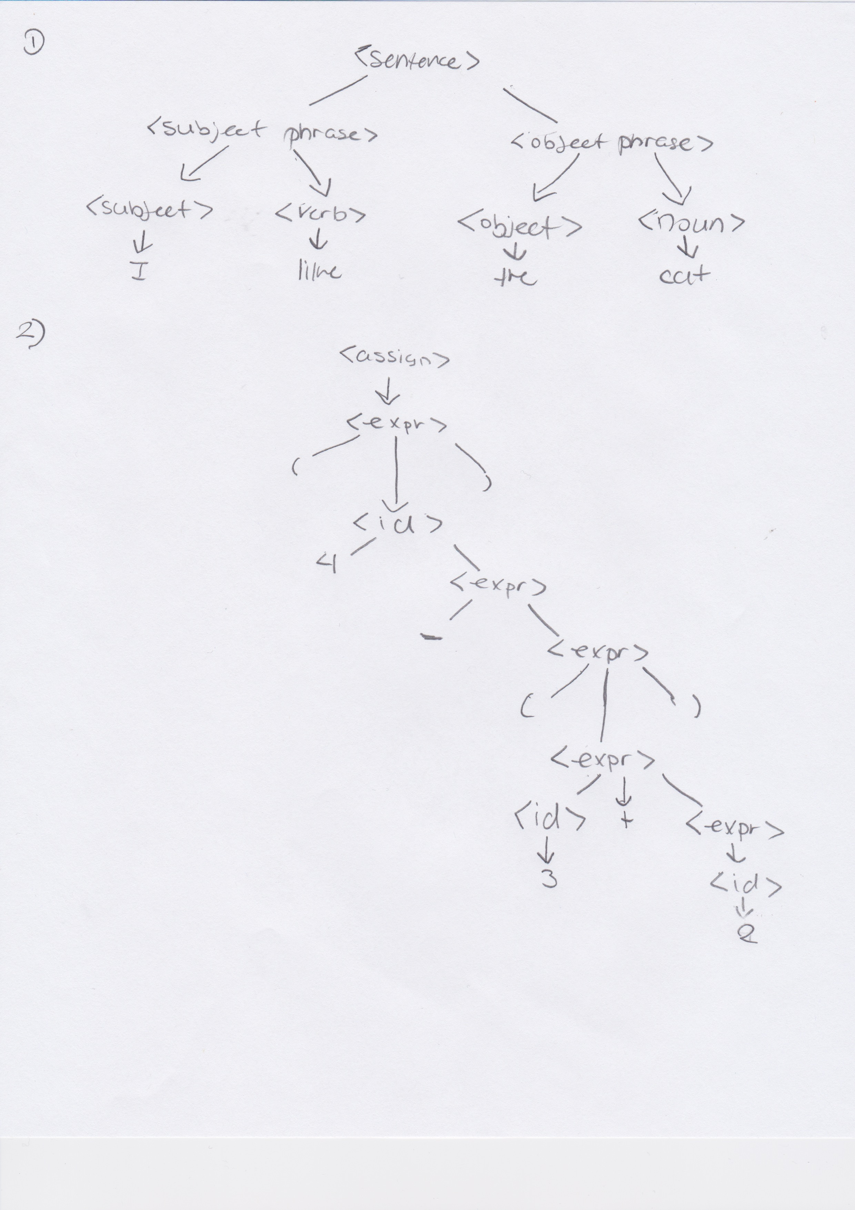

3. The following grammar is ambiguous because in this expression, the parse tree for this program has many different types and we won’t know what kind of parse tree would be used for this problem, therefore the problem is indeed ambiguous.

4.

a.

<A> : a|b|c

<digits> : i

b.

<A> : a|b|c

<digits> : 1 | 2 | 3 | 4 | 5 | 6 | 7 | 8 | 9

5.

a.

int main()

{

int n, i, sum = 0;

printf("Enter a positive integer: ");

scanf("%d",&n);

for(i=1; i <= n; ++i)

{

sum += i; // sum = sum+i;

}

printf("Sum = %d",sum);

return 0;

}

b.

int min(int x, int y)

{

  return y ^ ((x ^ y) & -(x < y));

}

c.

2var -> This is a lexical error because a number starts the first part of this program.

inx x = 1 - > This is a lexical error because inx is written wrong and it is supposed to be written as int.

d.

System.out.println(Hello World); - > This is because there are no quotation marks in front of the Hello World, therefore the whole thing is invalid and won’t work

System.out.println(Hello+World); - > Same thing as the other one, but this time it has a + in it, and usually it will come out in text, but it won’t work because it doesn’t have any quotation marks.

e.

fo (int i = 0; i < 0 -> This would be an error that not in lexical nor syntactic error, but a complier error.

int x;  
Console.println(x);

-> This is an error that is not lexical nor synaptic, but a semantic error.